**Ex 10**

**Date**

**MITM ATTACK WITH ETTERCAP**

**Aim:**

To initiate MITM attack using ICMP redirect with Ettercap tool.

**Algorithm:**

1. Install ettercap if not done already using the command-

***yum install ettercap-common***

2. Next start ettercap in GTK

***ettercap -G***

3. Click sniff, followed by **unified sniffing.**

4. Select the interface connected to the network.

5. Next ettercap should load into attack mode by clicking Hosts followed by Scan for Hosts

6. Click Host List and choose the IP address for ICMP redirect

7. Now all traffic to that particular IP address is redirected to some other IP address.

8. Click MITM and followed by Stop to close the attack.

**Output:**

[root@localhost security lab]# **yum install ettercap-common**

[root@localhost security lab]# **ettercap –G**

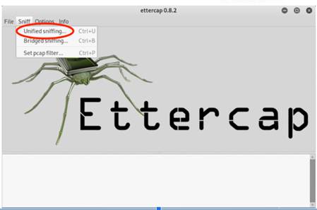

**Choose the appropriate interface**

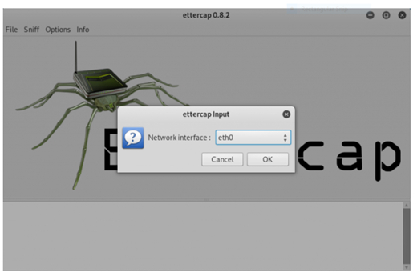

**Start scanning for hosts**

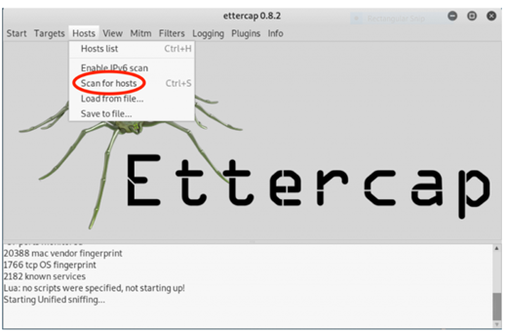

**Click Host List and choose the IP address for ICMP redirect**

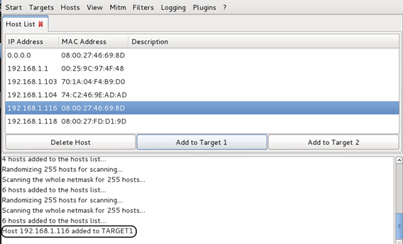

**Now all traffic to that particular IP address is redirected to some other IP address.**

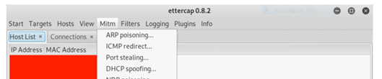

**Stop MITM attack**

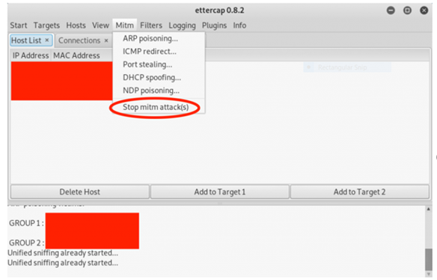

**Result:**

Hence MITM attack with ETTERCAP was implemented and analyzed successfully.